Frederick Brehm

CS 330

7/8/2024

Southern New Hampshire University

1. I am choosing to use a scene that is based off my kitchen. In the scene below you see that there is a kitchen sink, spicket, a soap dispenser, and a brush. My scene will be a little different than this scene as I will be including the sink, sponge, soap dispenser, and the faucet. The faucet will have made us of 2 or more 3D objects. The base of the faucet will be a cylinder, a torus will be the top of the base, an elongated cylinder will be used for the handle, and an elongated cylinder will be used for the actual faucet pipe.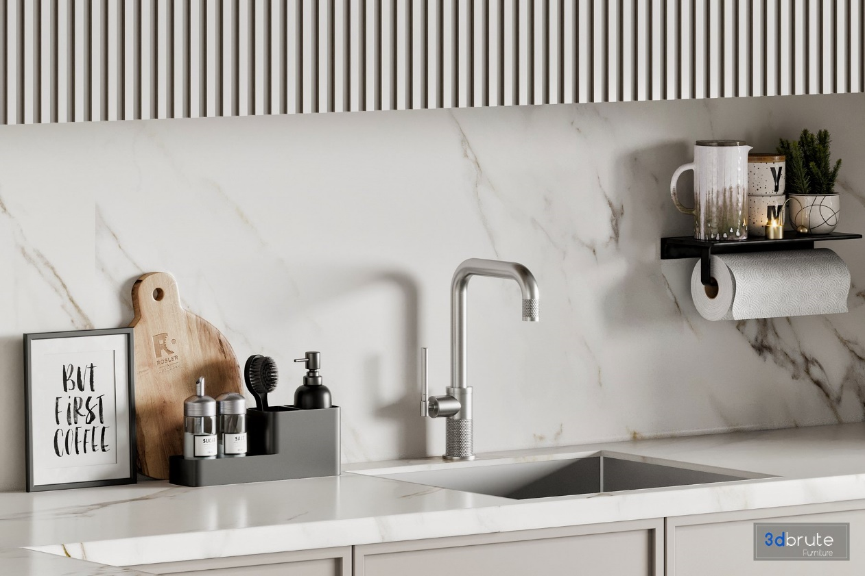

2. I will be using the soap dispenser and the sponge, sponge holder, and faucet as my 3D objects in this scene. All of these are great options for my work as they all range from simple to complex. The sponge holder shows simplicity as it is constructed from a simple plane. The sponge is also simple as it uses a box which will be elongated to create the rectangular shape of the sponge. The soap dispenser is more complex as it will require multiple cylinders and a torus to be used, and the faucet is the most complex as it has the most parts including multiple cylinders of different dimensions to create the finished faucet.

3. In my scene I chose to use a sink, soap dispenser, sponge, and sponge holder. In this project a plane must be used to ground the objects, which in this case a plane will be used as the counter that the objects sit on. A plane can also be used to show the open sink area that the dishes go into. In the picture there are triangles that help make the final shape of the sink, but I do not want to make this project too complex, so I will be using a plane to achieve the same result. The sponge holder will use a box that will be elongated with small cylinders on the bottom of each corner to show the “feet” of the sponge holder. The soap dispenser will be made from a cylinder for the base of the soap dispenser, a torus to round off the top of the body of the dispenser, a cylinder to make the pump portion, and a cylinder to create the mouth that the soap dispenses from. Lastly the faucet will use a cylinder for the base, a sphere to connect the handle to the base, a cylinder to represent the handle, and another cylinder to create the actual pipe portion of the faucet that the water will run out of.

These choices make sense as they all utilize a realm of 2D and 3D objects which are either simplistic or complex. However, the scene and objects I chose are not too complex to where I would not be able to successfully create them. I will carry out my work by working from the ground up. I will introduce the plane first to the counter, and after I will work each component from the ground to the top. This will help ensure that I am able to be accurate and precise with my objects but also so that I can create organized and readable code that is easy to understand.